Deployment Plan Template :

This deployment plan is a guide to implement a solution into a live production environment.

Minimum S/W requirement :

|  |  |
| --- | --- |
| JAVA | 1.6.0 |
| MAVEN | 3 |
| SPRING | 3.0.7 |

Steps to deploy Data Quality Application :

1. Copy the pcni.war file into Tomcat’s webapps directory

When tomcat reload features is enabled in the server , then one folder name pcni will be created in tht webapps directory.

Else need to restart the server.

1. Edit the context.xml file
   1. Webapps/pcni/META-INF/context.xml
   2. Here two resources are added .
      1. <Resource name="jdbc/dqDatabase"> : for authenticating logged in user
      2. <Resource name="jdbc/pcni"> : for fetching data to create reports/dashboard
   3. In this file give the database credentials. Here we have given database credentials same in both the resource.
2. Edit the project.properties file
   1. Webapps/pcni/WEB-INF/classes/project.properties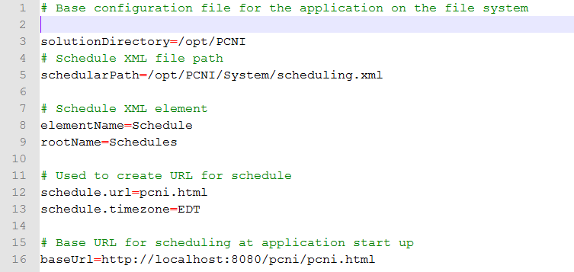
   2. This project.properties file is responsible to configure Application Settings and Scheduling related activity.
   3. In /opt/PCNI , actually we created the solution directory where all the dashboard files,sql query file,are there.
3. Edit the log4j.properties file
   1. Webapps/pcni/WEB-INF/classes/project.properties

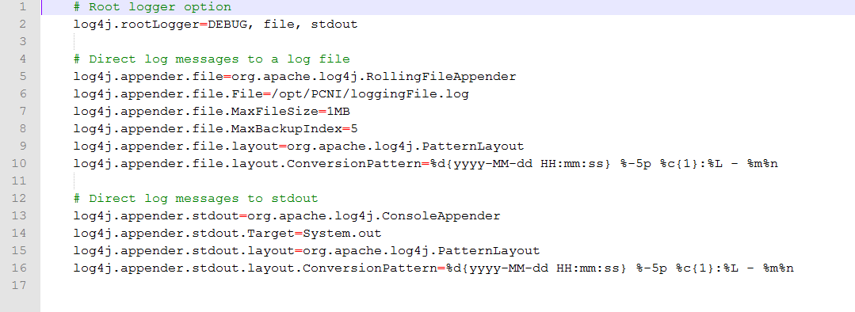

1. Mail configuration properties.
   1. This file is present in the System directory of the solution directory.
   2. /opt/PCNI/System/Mail/mailConfiguration.properties

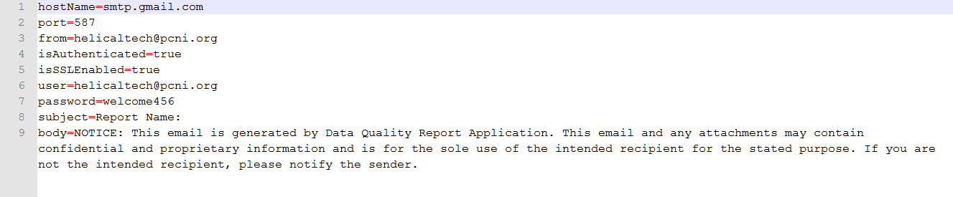

1. Need to give Read,Write,Execute permission (chmod 777) to below files :
   1. All the phantom relaed files present in deployed directory

Webapps/pcni/WEB-INF/classes/HDIPhantomjs/

* 1. All the files present in the Reports folder of Solution-directory /opt/PCNI/System/Reports/
  2. mailConfiguration.properties file present in solution directory

/opt/PCNI/System/Mail/

1. to make “Data Quality APR DK&R” and “Program Information ” template working in this DQApp, need to add below 5 stored procedures in the database.
   1. For Data Quality APR DK&R Template

 

* 1. For Program Information Template

  

NOTE : Database used for this application is : mysql.